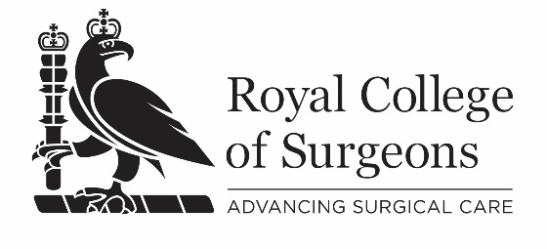
Replacement certificate
Payment details form

Please complete all sections of this form. Incomplete forms cannot be processed.

Title |  | Surname

Given name(s)

Address

Postcode |  | GMC number or equivalent

Email address

Name of course
Date(s) of course
Venue / course centre

If the course was held at a regional centre, please first check with them that they do not have your certificate.

Please debit my credit / debit card for £10

Card type: | MasterCard | Visa | Switch | Delta

Cardholder’s name

Card number
 |  |  |  | - |  |  |  |  | - |  |  |  |  | -

Expiry date |  |  |  |  |  | Start date |  |  |  |  |  | Security code |  | Switch issue no.
 |  | / |  |  |  |  |  | /

Signed / name if emailing |  | Date

This form will be securely destroyed once payment has been taken.

Please return your completed form to:
RCS Education, The Royal College of Surgeons of England,
35-43 Lincoln’s Inn Fields, London WC2A 3PE
Email: educationcertificates@rcseng.ac.uk

