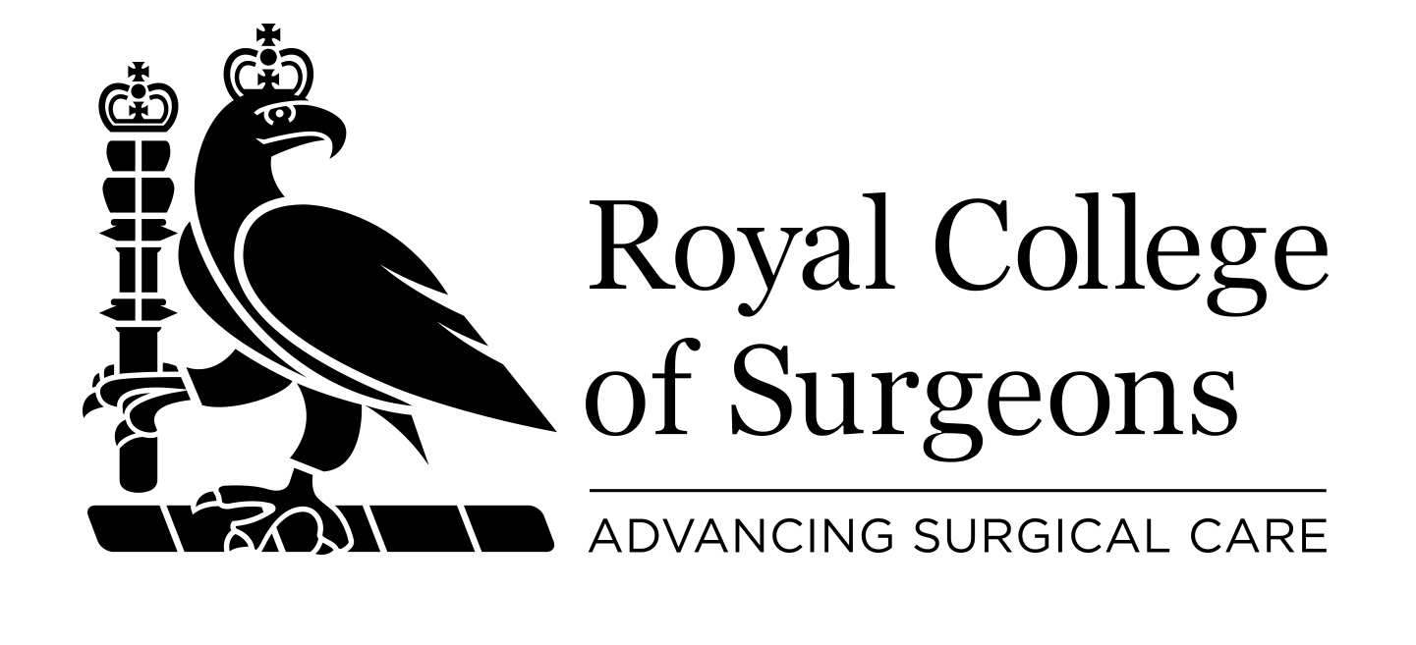 DONATION FORM

Please print and complete all sections
Your name
Your address
Postcode
Telephone email

I would like to make a donation to the Royal College of Surgeons of England for_______
General Funds □ | Surgical Research □ | Education □ | Hunterian Museum □ | Library □

Please make cheques payable to The Royal College of Surgeons of England or complete the details below to make a donation by credit/debit card.

Please debit my Access/VISA/Mastercard/Delta/CAF Charity Card/Switch:
Credit card number: _ _ _ _ / _ _ _ _ / _ _ _ _ / _ _ _ _
Security code: ……… Issue number: ……… Start date: ……… Expiry date: ………
Signature: ____________________________ Date: _________________

Gift Aid Declaration
By making a Gift Aid declaration you will allow the College to reclaim tax on your donation. You must pay an amount of income tax and/or capital gains tax at least equal to the tax that we will reclaim on your donations in the tax year (currently 25p for each £1 you give).


I would like The Royal College of Surgeons of England to treat all donations I have made since 6 April 2000 and all donations in the future as Gift Aid donations until I notify them otherwise. I am a UK taxpayer.

Signature: ____________________________ Date: _________________

Please return this form to: Development Office, The Royal College of Surgeons of England, 35-43 Lincoln’s Inn Fields, London WC2A 3PE

The information you have provided will be stored in accordance with the Data Protection Act 1998 and will not be passed on to third parties. We would like to keep you informed of College events and activities that may be of interest to you. Please tick this box if you do not wish to receive these mailings.□ Registered Charity Number: 212808

