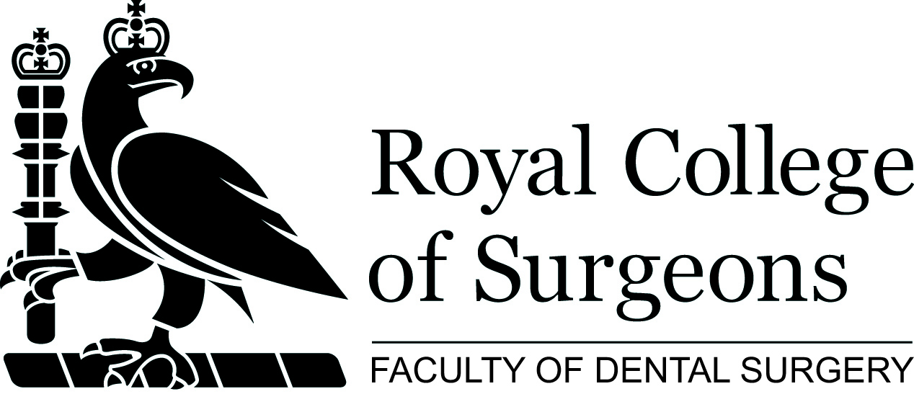

Faculty of Dental Surgery: course application form

Please note this form should only be used if you are unable to book online.
All courses are available to book, or register interest (if not yet open for booking) online at www.rcseng.ac.uk/courses

I wish to attend _______________________________________ Date__________________________________
Fee___________________________ (please state the fee that applies to your status e.g. member, affiliate, student)
Cheque for £_____________________ made payable to The Royal College of Surgeons of England
Please debit my card for £_____________________

Credit Card Details:

 | Mastercard |  | Visa |  | Switch |  | Delta
Credit Card No:
Expiry Date |  |  |  | Security Code [3 digits]

Contact Details:

Last Name in Full |  |  | Other Names
Title |  |  | Gender
Date of Birth |  |  | GDC No.
Tel No. / Mobile |  |  | Email Address
Please indicate how you heard about this course |  |  | Please indicate any dietary restrictions
Address

Postcode

The information you provide will be held on a College wide database and maybe shared with any relevant Specialist Associations located within the building. It will be use for relevant College mailings and used to process your application and stored in accordance with the Data Protection Act 1988.

We would like to keep you informed of other events and activities that may be of interest to you, please tick this box if you do not wish to receive these mailings.

Please note that there is a fixed cancellation charge of 10%. Cancellations made 4 weeks prior to a course will result in no refund. While we make every effort to run courses as advertised, we reserve the right to change the timetable and /or the teaching staff without prior notice and to cancel any courses without liability [in which case there will be a full refund of course fees to participants].

Registered Charity No. 212808

Please TYPE your details above and EMAIL your form to fdseducation@rcseng.ac.uk

Equal Opportunities Monitoring

In line with UK legislation and good practice guidelines, we are asking everyone to complete this section. You are not obliged to provide any of the information in this section, but if you do so, it will enable us to monitor our business processes and ensure that we provide equality of opportunity to all.

Name: | Ethnicity  Choose one selection from the list below to indicate your cultural background:  a) White:  British  Irish  Any other White background  b) Mixed  White and Black Caribbean  White and Black African  White and Asian  Any other mixed background  c) Asian or Asian British  Indian  Pakistani  Bangladeshi  Any other Asian background  d) Black or Black British  Caribbean  African  Any other Black background  e) Chinese or other ethnic group  Chinese  Any other background  Indicate a more specific category here:
Gender:
Nationality:
1st Language:
Do you have a disability under the terms of the Disability Discrimination Act 1995 (a person with a physical or mental impairment that affects you ability to carry out normal day to day activities which are substantial, adverse and long term)?
Yes
No

What is your sexual orientation?
Bisexual
Heterosexual
Lesbian or Gay

What is your religion or belief?
Buddhist
Christian
Hindu
Jewish
Muslim
Sikh
Other religion/belief
Indicate a more specific category here:

This information will be recorded electronically with your other data in accordance with the Data Protection Act 1998, but used only for monitoring our business practices.

Please return the completed application form to:

Faculty of Dental Surgery Tel: 020 7869 6815/6814/6813
Education Department Fax: 020 7869 6818
35-43 Lincoln’s Inn Fields Email: fdseducation@rcseng.ac.uk
London WC2A 3PE Web: www.rcseng.ac.uk/fds

