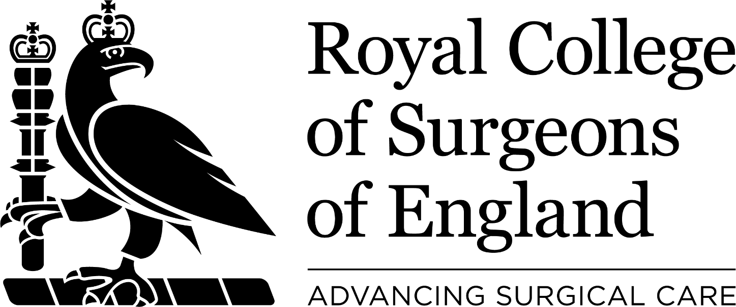
Diploma in Orthodontic Therapy
Job Description

1. JOB TITLE
Examiner for Diploma in Orthodontic Therapy of the Royal College of Surgeons of England

2. LINES OF ACCOUNTABILITY
Report to the Chair of the Board, through the Chair of the Panel of Examiners.
The Chair of the Board reports to the FDS Examinations Committee.

3. QUALIFICATIONS
The Examiner should hold the following:
- Full Registration with the General Dental Council
- Postgraduate qualification appropriate to the post
- Fellow or Member or Affiliate of RCS Eng

4. EXPERIENCE
- Be in active clinical and/or academic practice (or <1 year of retirement)
- Be motivated to maintain knowledge and skills
- Have attended, or be willing to undergo regular examiner training appropriate to the needs of the Examination
- Have attended or be willing to undergo equal opportunities and diversity training

5. JOB SUMMARY
- Be available to participate in diets of the Examination as requested by the Chair of the Panel of Examiners
- Attend the Adjudication Meeting for any diets of the Examination in which they have acted as an examiner
- Observe strict confidentiality with regard to the performance of individual candidates in the examination and the deliberations of the Adjudication Meeting
- Prepare and develop examining materials, questions, model answers and OSCEs for the Examination
- Participate in meetings of the Examining Panel as required by the Chair of the Panel of Examiners
- Act to promote the Examination on behalf of the RCS Eng

6. TIME COMMITMENT
- Examining – approximately 4 days per annum
- Examiner Training – 2 days of initial training followed by approximately 2 days per 5 year cycle
- Preparing examining material – approximately 1-2 days per annum

