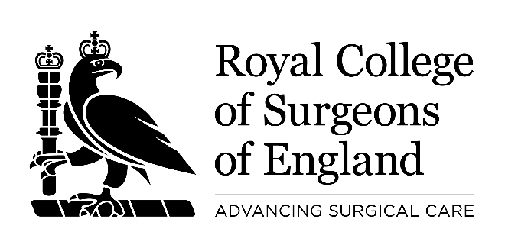
Registered Charity No 212808

DATA SUBJECT ACCESS REQUEST FORM

Please note that where the term “Data Subject” is used it refers to the person about whom the information is being requested.

- Details of person requesting the information

Full Name

Address

Tel No

Email

Date of Birth and/or GMC Number

2. Are you the data subject?

YES: If you are the Data Subject please supply evidence of your identity i.e. copy of driving licence, passport, or birth certificate. (Please go to question 5)

NO: Are you acting on behalf of the Data Subject with their written authority? If so, the evidence of appropriate authority must be enclosed. (Please complete questions 3 and 4)

3. Details of the Data Subject (if different to 1)

Full Name

Address

Tel No

Email

4. Please describe your relationship with the Data Subject that leads you to make this request for information on their behalf.

5. Please describe the information you seek together with any other relevant information. This will help to identify the information you require. The more details you will provide us with, the more accurate and fast our response will be. An example of how to formulate the request can be found at https://ico.org.uk/your-data-matters/your-right-to-get-copies-of-your-data/preparing-and-submitting-your-subject-access-request/

Declaration: To be completed by all applicants. Please note that any attempt to mislead may result in prosecution.

I ……………………………………………………………………………, certify that the information given on this application form to the Royal College of Surgeons of England is true. I understand that it is necessary for the College to confirm my/Data Subject’s identity and it may be necessary to obtain more detailed information in order to locate the correct information.

Signature

Date

Note: The Royal College of Surgeons of England must respond to the request within 1 calendar month, which can be extended by further 2 months for complex queries. The 1 calendar month starts when the request has been made valid and proof of identity has been obtained.

Please return the completed form and associated documents to the Data Protection Officer via email dpo@rcseng.ac.uk or via post; Data Protection Officer, Executives Office, Royal College of Surgeons of England, 35-43 Lincoln’s Inn Fields, London, WC2A 3PE.

Documents which must accompany this application:
- evidence of your identity
- evidence of the data subject’s identity (if different from above)

The information you provide will only be used for the purposes of conducting a data subject access request and will be held securely for up to two years by the Data Protection Officer before it is destroyed. In the event of repeated requests or challenges to the DSAR process this information may be retained longer as evidence of our processes. If you have any questions about this form or the way this information is used please contact the Data Protection Officer, via one of the methods listed above.

