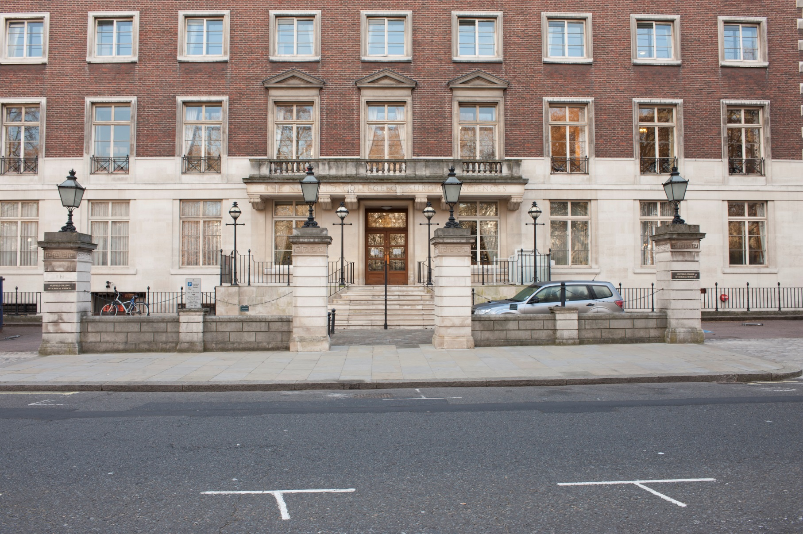

Access Guide 2018-2020

Introduction

Welcome to the Royal College of Surgeons of England.
• This access guide is for all disabled visitors to the College site.
• There is information to help you plan your journey to the College by car and public transport.

• You can find details of how to access the building as well as information about the services for disabled visitors on offer in the College.

• This guide provides the main contact details for the College.

• We hope that this guide facilitates your visit to the College.

Address
The Royal College of Surgeons of England
35-43 Lincoln’s Inn Fields
London
WC2A 3PE

Contact details
Telephone: 020 7405 3474
Textphone/Typetalk users: 18001 020 7405 3474
www.rcseng.ac.uk/about-the-rcs/contact
About the College
• The Royal College of Surgeons of England is at 35-43 Lincoln’s Inn Fields, on the south side of the square. This is in central London near to Holborn and Covent Garden.

• The College occupies two buildings on this site. The main building is currently closed and undergoing major redevelopment. It is due to reopen to visitors in late 2020 with greatly improved access facilities.

• The other building to the left of the main building is the Nuffield College of Surgical Sciences. This is a brick building with a set of nine steps and an external access lift to the right of the steps.

• The College is open to visitors Monday to Friday, 9am to 5pm.

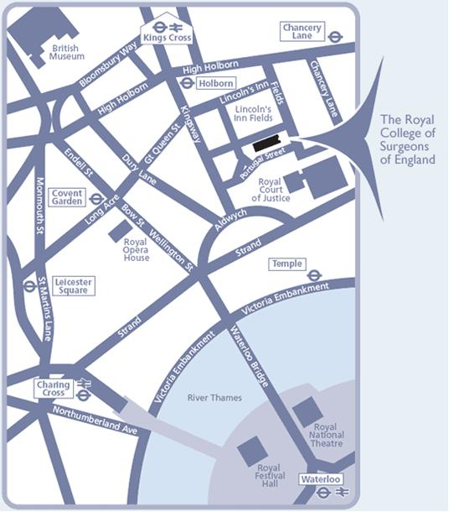

How to get to the College

Car
• On street parking is available outside the College on Lincoln’s Inn Fields. Parking is operated via a ‘Pay by Phone’ system and controlled hours are in operation from Monday to Saturday, 8.30am – 6.30pm. The current charge in the Westminster bays is £4.90 per hour with a maximum stay of 4 hours.

• Visitors should be aware that both Westminster and Camden councils operate parking bays around the Fields. Please check the signs carefully when you park to determine which borough you are parked in and ensure you purchase a correct ticket.

• Blue Badge holders can park in marked bays for up to 4 hours, Monday to Friday, 8.30am to 6.30am, and without time limit outside these hours. As a Blue Badge holder you are also entitled to park at a meter/pay-and-display bay for an extra hour once the maximum paid time has expired.

• For more information see the Westminster council website: https://www.westminster.gov.uk/disabled-parking

• The nearest multi-storey car parks are in Drury Lane and Bloomsbury Square.

College parking for disabled people
• The College has a dedicated parking space for use by disabled visitors. Please book this space in advance by calling 020 7869 6400.

Underground
• The nearest Tube station is Holborn (Piccadilly and Central Lines). It takes about 10 minutes to walk from the station to the museum.
• Temple (District and Circle Lines) and Charing Cross stations (Northern and Bakerloo Lines) are a 10-20 minute walk or short taxi ride away.

Bus
• A number of buses stop near the College:-
High Holborn (travelling east and west)
1, 8, 25, 38, 55, 98, 242
Kingsway (travelling north and south)
1, 59, 68, 91, 168, 171, 188, 243, 521
Aldwych (travelling east and west)
9, 11, 15, 23, 341
Aldwych (travelling north and south)
4, 6, 26, 76, 139, 172, 176, 341

• For more details, download route maps from tfl.gov.uk:
http://content.tfl.gov.uk/bus-route-maps/holborn-170617.pdf
http://content.tfl.gov.uk/bus-route-maps/aldwych-a4-300917.pdf

Rail
• The nearest mainline stations are Kings Cross St. Pancras, Euston, Waterloo and Charing Cross.

• It takes about 20-30 minutes to walk from each to the College.

Entering the College Buildings
• Currently, the main college building is undergoing major redevelopment until late 2020. For the duration of this work, all staff and operations have moved to the Nuffield School of Surgical Sciences building to the left of the main building.

• The entrance to the Nuffield reception is up a flight of 9 steps. There are handrails to the left, right and up the centre of the steps.

• To the right of the steps is an accessible lift. Instructions for operating the lift can be found on the lift door. Prior to accessing the lift, use the call button beside the lift to notify staff so that they can provide you with assistance into the building.

• At the top of the steps you are required to press the black doorbell so that staff can ‘buzz’ you in through the main doors. These are very heavy and if you do not enter the building shortly after this, staff will come to see if you need assistance.
• Once through the main doors, the second set of lobby doors open automatically

• All visitors should go to the reception desk on the left side of the lobby on arrival. Reception staff will provide directions to the relevant meeting room or contact a College staff member for you.
• The reception desk is staffed at all times during working hours.

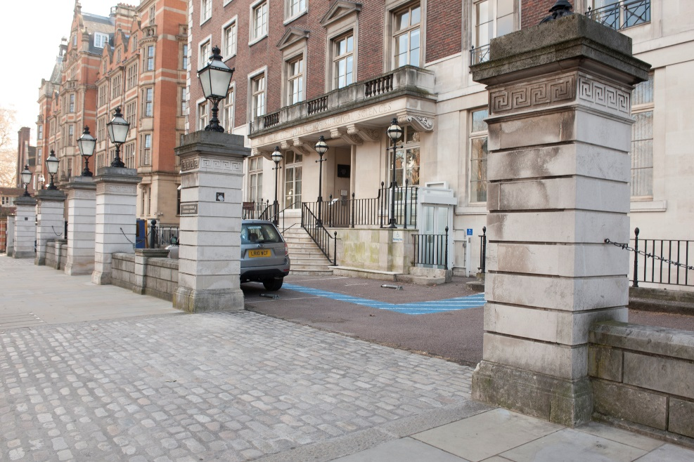
Nuffield Building showing external access lift
Facilities and Services

Personal Emergency Evacuation plan (PEEP)
• Visitors who would require assistance during an emergency evacuation should complete a ‘Personal Emergency Evacuation Plan’ (PEEP) on entering the building.

• This is a bespoke 'escape plan' for individuals who may not be able to reach an ultimate place of safety unaided or within a satisfactory period in the event of any emergency.

• Please speak to the reception desk on arrival to arrange this.

Dogs
• Guide dogs, hearing dogs and other assistance dogs are welcome in the College.
Toilet
• There is a unisex accessible toilet on the ground floor of the building in the Nuffield Lounge

Nuffield Lounge
• Visitors to the College are welcome to use the Nuffield Fellows lounge

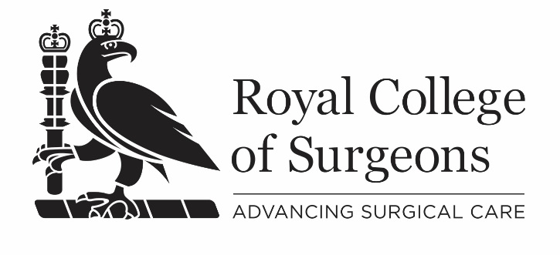
The Royal College of Surgeons of England
35-43 Lincoln’s Inn Fields
London WC2A 3PE
T: 020 7405 3474
W: www.rcseng.ac.uk
Further reading
Text

Text

Published: January 2018
Head of Learning & Access
Museums & Archives Team
www.rcseng.ac.uk

