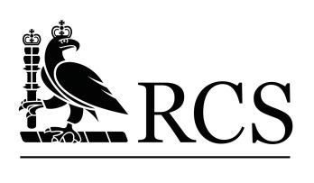

CALL FOR POSTERS

‘Tough Challenges for surgery – the surgical care of the young’

The Royal College of Surgeons of England (RCS) is running a poster exhibition as part of its Global Surgical Frontiers Conference, which is taking place on Friday 21st and Saturday 22nd April 2017 at the RCS, in London.

The conference main theme builds on from the work of the Lancet Commission on Global Surgery, launched in 2015, with the focus on the global surgery for the young.

Alongside the conference, we will be displaying the best 10 posters shortlisted from surgical trainees, medical students, and researchers with a particular interest in Global Surgery, focused on the theme: ‘Though Challenges for surgery – the surgical care of the young’.

To apply, please send your 250 word abstract to internationalteam@rcseng.ac.uk by Monday 26th February 2017 – stating your name and research affiliation.

The best 10 abstracts will be invited to present a poster on the proposed topic, which will be displayed during the Global Surgical Frontiers Conference.

What’s in it for you?

This is a great opportunity to showcase your research related to Global Surgery among an audience of UK and international global surgery experts. Your poster will be displayed during the Global Surgical Frontiers Conference, in the main exhibition hall, where all delegates will be having coffee breaks and lunch. You will also have the chance to network and find out more about the RCS and other organizations’ work in relation to Global Surgery.

If you wish to find out more, or have any questions, please feel free to contact us at internationalteam@rcseng.ac.uk

