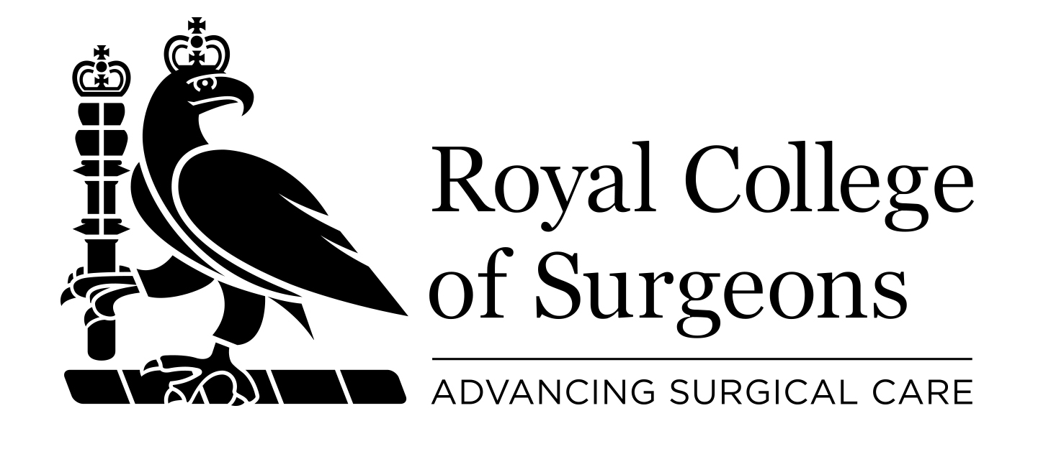

INTERNATIONAL ADVISERS

Terms of Reference

- INTRODUCTION

The Royal College of Surgeons of England is a professional membership organisation and registered charity, which exists to advance patient care. We support 20,000 members in the UK and internationally by improving their skills and knowledge, facilitating research and developing policy and guidance.

The College’s international membership makes up 25% of the current membership, with members from over 90 countries. International Affairs is responsible for leading all RCS work with a focus outside UK. Our intention is that our networks of members constitute an important source of “market intelligence” and local knowledge from which we will gather information to inform our strategy and identify projects, either of developmental or paid services, depending on the national context.

RCS International Affairs recognises the importance and value of its members, particularly in the development and advancement of surgical standards overseas. They constitute a body of knowledge, expertise and experience, in particular concerning surgical needs and institutions in their country which is invaluable to RCS development of a pro-active strategy for international engagement.

- FUNCTION AND REMIT

The International Adviser is an honorary role which will play an important and strategic role for the College within a specific country. He/she will act as key point of contact for members in these countries and RCS International Affairs with the view to engaging with global surgical issues.
The International Adviser will be responsible for developing appropriate strategic relationships, for example with government, education, training and healthcare organisations within their respective countries based on the direction of the RCS International work and strategic aims.
Key aspects of the role include, but are not limited to:

- Contributing to the development and implementation of the College’s international strategy (the ‘Strategy’) and leading on the formulation of engagement plans for the respective country.

- Maintaining effective communication with RCS International Affairs, including ascertaining the views and concerns of members and stakeholders on relevant issues and adequately reporting these views to RCS International Affairs.

- Establishing and maintaining positive relationships with and contacts, by regularly producing a report on the work progress to RCS International Affairs.

- Identifying emerging issues and advising RCS International Affairs on the implications related to any of its country Government policies, change in practice developments, strategies or discussions regarding surgery.

- Advising the RCS International Affairs generally, including identifying any opportunities which may exist to extend the College’s influence; strengthen or build the RCS profile by consolidating its position in terms of good surgical standards.

- The role of International Adviser is an honorary role and will not attract a salary, expenses or any other form of remuneration

- APPOINTMENT

- Countries
RCS International Affairs wishes to appoint International Advisers, initially within the Department for International Development (DFID) 28 target countries which form the focus of the College’s new Strategy on building surgical capacity in Low and Middle Income Countries (LMICs).

- Eligibility
ESSENTIAL
International Advisers MUST:
- Be a Fellow of RCS England
- Be in good standing with the relevant national medical body
- Be a surgeon residing in one of the indicated countries
- Have a good understanding of the RCS International Strategy and willingness to advancing it in their country of residence
- Currently practise surgery
- Have 2 references from surgeons in good standing, if possible one from a RCS member
- Possess good knowledge and awareness of their country’s Healthcare and Medical systems, including well-established contacts with Government and private institutions and stakeholders
- Be capable of providing accurate advice on a range of professional, political and educational issues as needed to support the development and delivery of RCS’s strategy internationally, and specifically in their country of residence

DESIRABLE:
- Have existing and established contacts with key healthcare institutions, including government, in their country
- Good understanding of the political, socio-economic situation of their country
- Understanding of Due Diligence Processes

- Procedure
- The procedure to appoint an International Adviser is determined and overseen by the RCS International Affairs, which will advertise the post and invite expressions of interest from the RCS membership, in the relevant country.
- The following factors will be taken into consideration:
- The number of members within the country
- The number of application or expressions of interest received
- The current and prospective activities of the College within the candidate’s country and his or her application or profile
- Candidates applying for the RCS International Advisers’ role will need to demonstrate, amongst other things, the following skills and attributes:

- A commitment to promoting the RCS England, its services, qualifications, examinations and standards within the specified country and in the UK
- Knowledge and understanding of Surgical Education, Training and Research in his/her country
- Well established contacts with surgeons and relevant health institutions or Government agencies within his/her country.
- Keen Involvement in membership of networks, forums or associations within the country
- Ability to be proactive and work as part of a team
- Ability to inspire others
- An interest in supporting the International Team in developing new College-supported activities, in line with the International Strategy, for surgeons and any other relevant health care professionals in the country

- TERM
International Advisers will be appointed for a term of two years. The term will be renewable for a further period of two years, subject to approval by the RCS International Affairs.

- ACCOUNTABILITY AND REPORTING

Once appointed, International Advisers will be accountable to the RCS International Affairs and will be expected to:

- Participate in their respective countries in their professional relationships and through attendance at national and/or regional meetings, when required. Advisers will describe themselves as the ‘RCS International Adviser’ for the relevant country, when promoting as appropriate the College’s international activities, vision and mission.

- Actively contribute to the development and implementation of the RCS International Strategy and programmes, attending all meetings requested by the RCS International Affairs and providing written reports.

- Provide advice in respect of their respective countries, particularly in terms of proposed projects.

- Promote and raise awareness of education, training, research and practice issues and developments within the country amongst the wider College membership using the College website, quarterly Bulletin, College events or meetings and the College Social media, via International Affairs.

- Keep up-to-date with the College’s work in training, examinations and continuing professional development both in the UK and in the country where he/she is acting as International Adviser.

- Submit reports, as and when required by the International Affairs, but at least twice annually, which describe the world of surgery, identifies needs to which the college could respond, or identifies project or contract opportunities in their country of residence

- Write articles for RCS publications and website, if requested

- To make professional recommendations to International Affairs (e.g. identify institutions with whom we might partner)
- To alert RCS International Affairs to opportunities related to RCS expertise, including new project opportunities, new partnership opportunities, examinations, education, accreditation, Quality Assurance, curriculum development, research fund raising and relevant congressed or conferences
- Advise on potential partner institutions in their home country for other collaborations with RCS International Affairs, contributing to Due Diligence exercises.
- Attend meetings requested by the RCS International Affairs (either virtually or face-to face)

- REVIEW

All RCS International Advisers posts are subject to an annual review to ensure that they remain relevant and effective. The following will be considered when undertaking this review:

- The Terms of Reference for the International Advisers’ Role
- International Adviser performance in relation to impact and success, taking the RCS International Strategy forward
- Any issues or challenges affecting the International Adviser’s ability to fulfil the requirements of the role

- APPENDICES

- RCS International Affairs Strategy
- Application form for RCS International Adviser

Afghanistan, Bangladesh, Burma, Democratic Republic of Congo, Ethiopia, Ghana, India, Kenya, Kyrgyzstan, Liberia, Malawi, Mozambique, Nepal, Nigeria, Occupied Palestinian Territories, Pakistan, Rwanda, Sierra Leone, Somalia, South Africa, Sudan, South Sudan, Tajikistan, Tanzania, Uganda, Yemen, Zambia, Zimbabwe.

