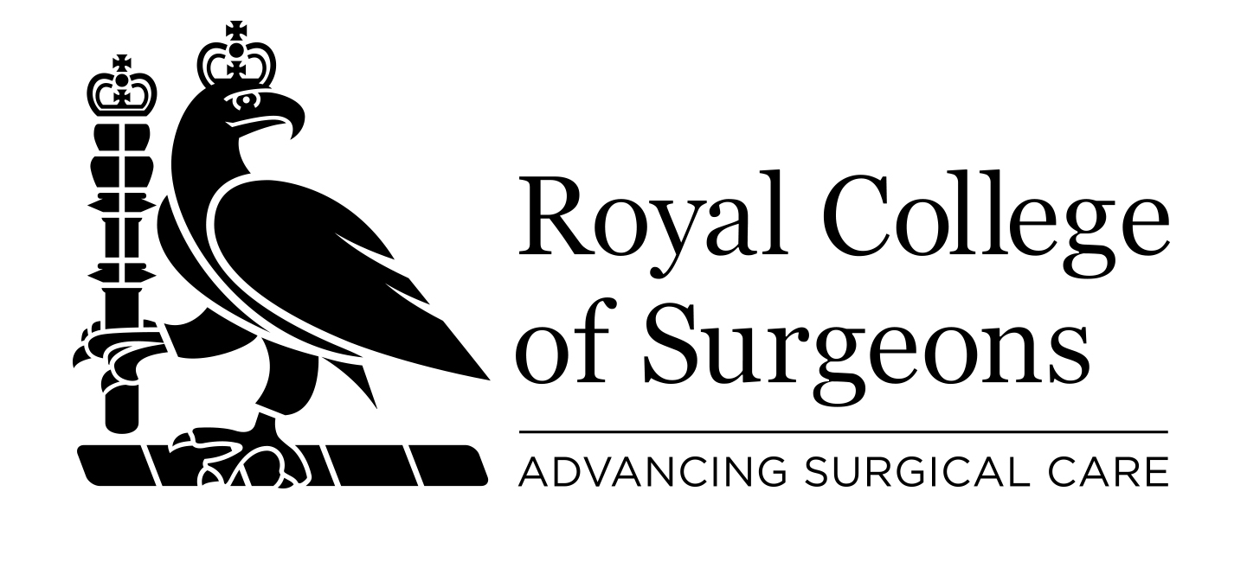

International Surgical Training Programme (ISTP)
  - UK Trust Post Submission Form

DETAILS OF TRUST
Employing organisation:
Main place of work:
LETB / Deanery:

DETAILS OF POST AND TRAINING
Job Title: International Surgical Trainee
Specialty/Specialties of Post:
Start date of post: | End date of post (12-24 months):
Hours of work per week (maximum = 48):
Source of funding for the post:
Is this post part of a rotation? |  | Yes No
Is this rotation undertaken jointly with another Trust? |  | Yes No
If YES, is the Trust aware of this rotation? |  | Yes No
Does this post meet the GMC standards for education and training? |  | Yes No
Has funding been secured for this post? |  | Yes No
Does this post have the appropriate study leave allotted? |  | Yes No

ROTATION DETAILS - PLACEMENTS
 |  | Hospital/Centre | Specialties | Duration (months) | Education Supervisor  (Name and email)
 | 1.
 | 2.
 | 3.
 | 4.
 | Additional information:
 | Please tick this box to confirm that the surgical trainee appointed to this post will have an educational contract or other appropriate agreed training programme and support (including access to facilities, training opportunities etc.) and undergo appropriate appraisal and assessment
 | Please tick this box to confirm that the surgical trainee appointed to this post will have an appropriate Supervising Consultant, from within the NHS Trust, allocated for the period of their placement.

DETAILS OF THE SUPERVISING CONSULTANT
Name:
Position:
Telephone number: | Email:

TO BE COMPLETED BY THE MEDICAL STAFFING / SERVICE MANAGER / CLINICAL DIRECTOR
Name:
Position:
Telephone number: | Email:
The RCS charges a £1,500 (+ VAT) placement fee per trainee for processing applications. In the case that the trainee is rotating between more than one trust, the placement fee will be split amongst the recruiting trusts and invoiced accordingly.

Please tick this box to confirm that the ISTP fee has been accepted.

Signature: | Date:

Please submit this completed form and the detailed job description to:

MTI Officer
International Office
Royal College of Surgeons of England
35-43 Lincoln’s Inn Field
London WC2A 3PE
e: mti@rcseng.ac.uk
t: 020 7869 6634

