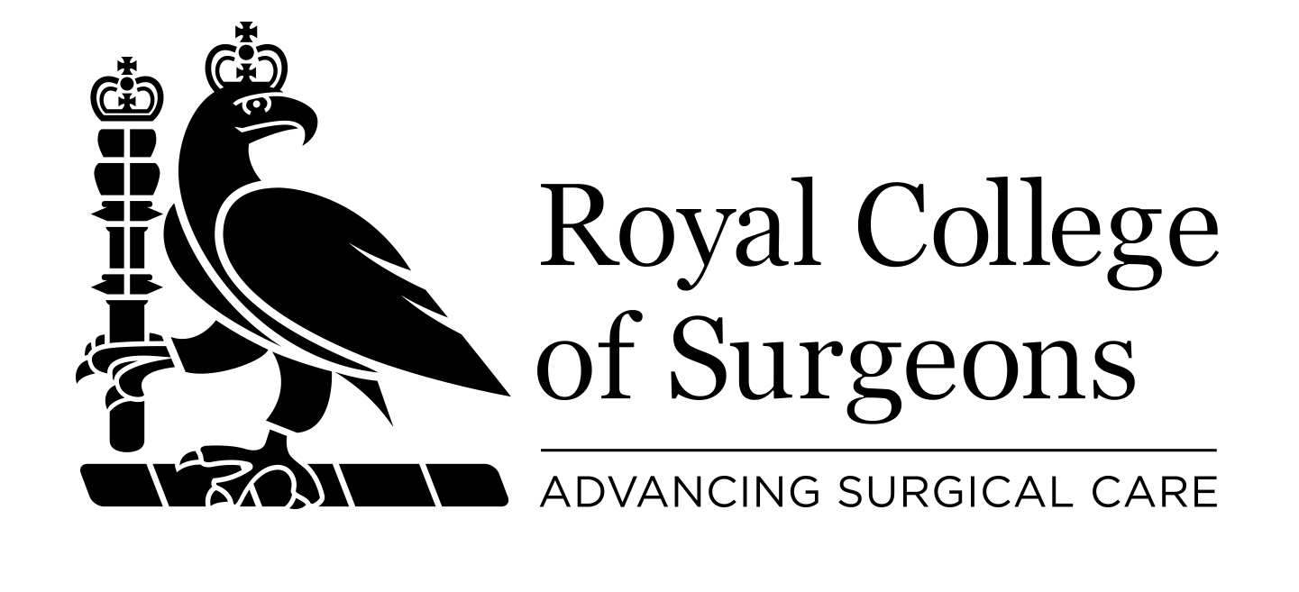 GIFT AID DECLARATION

Please complete in block capitals.

1. Your details

Title: _________ First name: ___________________Surname:_____________________

Address:____________________________________________________________________________________________________________________________________________________________________________________Postcode: _________________

Telephone number (in case of query): ___________________________
E-mail address: ____________________________________

2. Your declaration

By making a Gift Aid declaration you will allow the College to reclaim tax on your donation. You must pay an amount of income tax and/or capital gains tax at least equal to the tax that we will reclaim on your donations in the tax year (currently 25p for each £1 you give).


I would like The Royal College of Surgeons of England to treat all donations I have made since 6 April 2000 and all donations in the future as Gift Aid donations until I notify them otherwise. I am a UK taxpayer.

Signature:____________________________ Date:__________

Please return this form to: Development Office, The Royal College of Surgeons of England, 35-43 Lincoln’s Inn Fields, London WC2A 3PE

The information you have provided will be stored in accordance with the Data Protection Act 1998 and will not be passed on to third parties. We would like to keep you up-to-date with College news and events that may be of interest to you. Please tick the box if you would prefer not to receive mailings from us □.

Registered Charity Number: 212808

