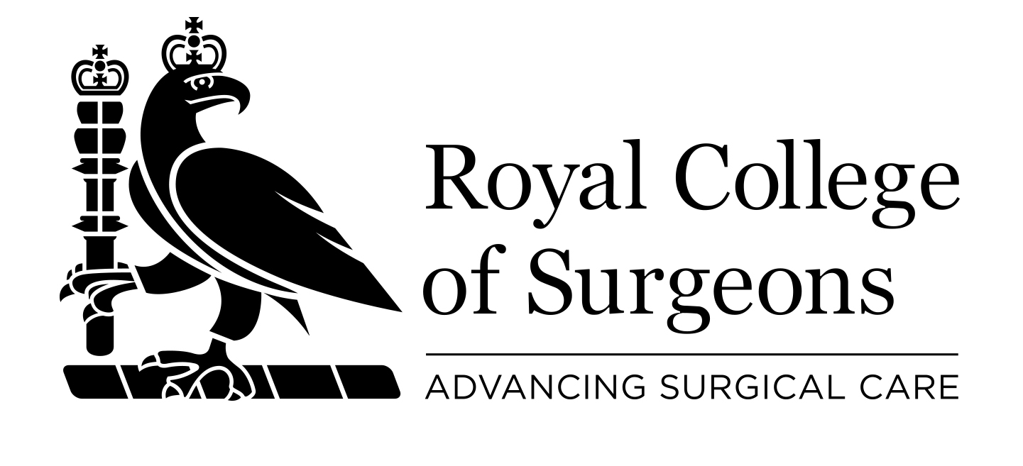 Standing Order Form
If you are setting up to make a regular contribution to The Royal College of Surgeons of England we would ask you to complete the form below, together with a Gift Aid declaration (for UK taxpayers).

Please complete in block capitals.

- Your details

Title:_____ First name: ________________________ Surname: ________________________
Address: _____________________________________________________________________
_______________________________________________________Postcode: _____________
Telephone number (in case of query):_________________ E-mail address:_________________

2. Your regular gift

It is my intention to set up a standing order donation to the Royal College of Surgeons of England for

Core Activities □ | Research □ | Education □ | Hunterian Museum □ | Library □

Please pay to The Royal College of Surgeons of England, C Hoare & Co. Bankers, 37 Fleet Street, London EC4P 4DQ Bank sort code: 15-99-00 For account no: 91650022 (Appeals Deposit Account)
£10 □ £50 □ £100 □ or my preferred amount of £_________________(amount in figures)
£_____________________________________________________________ (amount in words)
Each month / quarter / year* from my account for ______ years / until further notice*.
(*delete as appropriate) Starting on: ___ / ___ / ___
My account number: ____________________________ Sort code: _____ - _____ - _____
Bank details: _________________________________________________________________
____________________________________________________Postcode: _______________
(name and address of your bank)

3. Gift Aid declaration

By making a Gift Aid declaration you will allow the College to reclaim tax on your donation. You must pay an amount of income tax and/or capital gains tax at least equal to the tax that we will reclaim on your donations in the tax year (currently 25p for each £1 you give).

I would like The Royal College of Surgeons of England to treat all donations I have made since 6 April 2000 and all donations in the future as Gift Aid donations until I notify them otherwise. I am a UK taxpayer.


Signature:________________________________ Date: _____________________

Please return this form to: Development Office, The Royal College of Surgeons of England, 35-43 Lincoln’s Inn Fields, London WC2A 3PE

The information you have provided will be stored in accordance with the Data Protection Act 1998 and will not be passed on to third parties. We would like to keep you up-to-date with College news and events that may be of interest to you. Please tick the box if you would prefer not to receive mailings from us □.

