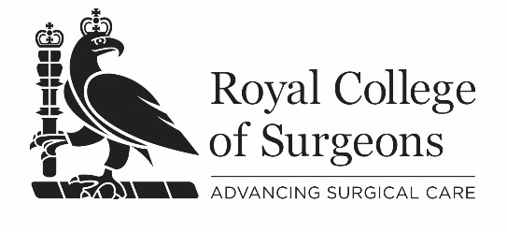
Participant feedback questionnaire: face-to-face course – short version

Course title:
Course date: | Dd/mm/yyyy
Course provider:
Course venue:
1:strongly disagree; 2:disagree; 3:neutral; 4:agree; 5:strongly agree; n/a not applicable
1. Participants’ suitability for the course was clearly defined. [Q4]. |  | 1 | 2 | 3 | 4 | 5 | n/a
2. The course administration was effective: Pre-course (e.g. joining instructions, programme, directions to centre) [Q5a] |  | 1 | 2 | 3 | 4 | 5 | n/a
3. The pre-course learning materials/activities were helpful preparation for the course. [Q7] |  | 1 | 2 | 3 | 4 | 5 | n/a
4. The learning outcomes of the course were clearly defined. [Q8] |  | 1 | 2 | 3 | 4 | 5 | n/a
5. The course was held in an environment which was suitable for achieving the course learning outcomes. [Q10] |  | 1 | 2 | 3 | 4 | 5 | n/a
6. The delivery methods were appropriate for achieving the learning outcomes. [Q11] |  | 1 | 2 | 3 | 4 | 5 | n/a
7. The structure of the course was appropriate for achieving the learning outcomes. [Q12] |  | 1 | 2 | 3 | 4 | 5 | n/a
8. The number of faculty was sufficient to support achievement of the learning outcomes. [Q16] |  | 1 | 2 | 3 | 4 | 5 | n/a
9. The faculty demonstrated the appropriate level of knowledge and skills to effectively deliver the learning outcomes. [Q17] |  | 1 | 2 | 3 | 4 | 5 | n/a
10. If there were any areas of the course that you thought were particularly strong or weak, or that were not covered in the questions, please record your comments below. [Q30]
Free text:

v@26.10.17

