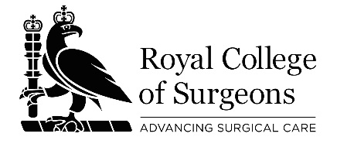

ROYAL COLLEGE OF SURGEONS

Accredited Surgical Education Centres and Organisations

Six-monthly update

Due on 1 June and on 1 December in each year of the period of accreditation

Please complete and return the following questionnaire to qa@rcseng.ac.uk

1.Name of Surgical Education Centre / Organisation:

2.Date of most recent accreditation of your Centre / Organisation (mm/yyyy):

3.Surgical education courses / activities which are currently included under the terms of your accreditation:

4.New surgical education courses / activities which you wish to be included under the terms of your accreditation (please attach details of these activities, including the programme, specification, faculty):

5. Surgical education courses / activities which are currently included under the terms of your accreditation, but which you will no longer be providing:

6.Any other changes at your Centre / Organisation which have occurred since your most recent accreditation / update provided to the RCS, or which you are planning:

v@18.12.17

