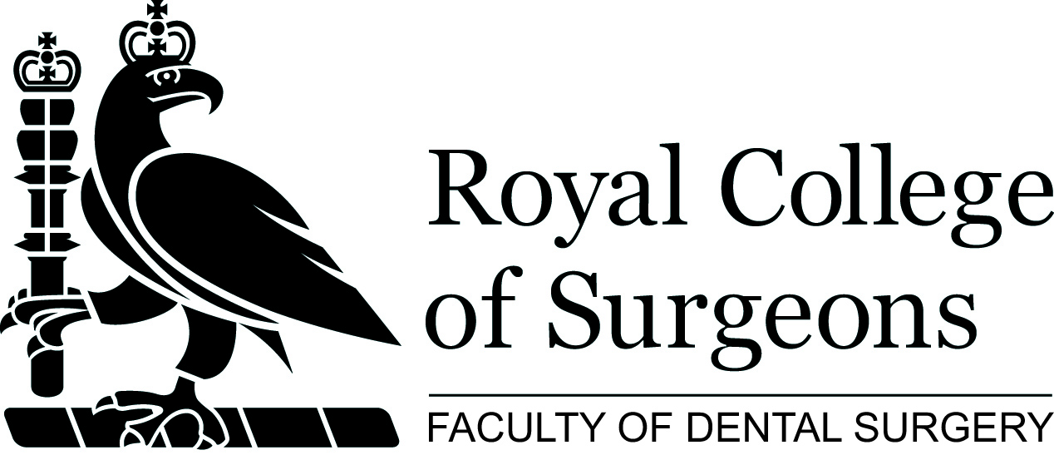

Joint Paediatric-Orthodontic Day: A Team Approach to Children’s Dental Care

The Met Hotel, Leeds: 8 November 2018

Within the dental environment, both paediatric and orthodontic colleagues often refer to each other and provide care for the same patient. This course will focus on key areas that impact on both paediatric and orthodontic colleagues, and will cover the best contemporary approach to the treatment of a range of some common, less common and yet challenging conditions.

The course will be of interest to all paediatric and orthodontic colleagues and will focus on the key overlap between the specialities and how they can work together to provide the best evidence-based approach.

Educational Aims & Objectives:
- Update on contemporary treatment of patients who have sustained dental trauma and possible subsequent orthodontic treatment
- Provide an evidence-based approach to interceptive orthodontics in children
- Discuss an Interdisciplinary approach for patients with complex medical histories
- Provide an overview of contemporary treatment of patients who present with amelogenesis imperfecta and a malocclusion
- Describe a team-based approach to hypodontia in children
- Explore MCNs: how to make them work for paediatric dentists and orthodontists
- Look at why we need to be more innovative in the dental care of children

Venue
The Met Hotel, Kings Street, Leeds LS1 2HQ

This study day will attract 5 hours of verifiable CPD.

Please return your completed application form to the:

Education Department
Faculty of Dental Surgery
The Royal College of Surgeons of England
35-43 Lincoln’s Inn Fields
London WC2A 3PE

Telephone: 020 7869 6813/6814
Email: fdseducation@rcseng.ac.uk
Web: www.rcseng.ac.uk/fds

Programme
Time | Topic | Faculty
0830-0920 | Registration
0920-0925 | Welcome | Faculty of Dental Surgery
0925-0930 | Introduction | Mrs Claire Stevens  Course Co-Convenor  Consultant in Paediatric Dentistry  University Dental Hospital of Manchester
0930-10.10 | Inter-disciplinary treatment in patients with complex medical histories | Kay Hood
1010-10.50 | Severe combined immunodeficiency - implications for paediatric dentists & orthodontists | Frankie Soldani
10.50-1115 | Morning refreshment break
1115-11.45 | Amelogenesis imperfecta & malocclusion – a contemporary combined approach | Simon Littlewood
11.45 – 12.45 | Update on trauma injuries in patients with malocclusions | Jay and Susan Kindelan
12.45 – 13.00 | Question & Answer session with morning speakers | Facilitated by Claire Stevens
13.00-1345 | Lunch
1345 - 1425 | Treatment planning for hypodontia cases in children | Sophy Barber
1425 - 1505 | Contemporary interceptive orthodontics - when to step in with paediatric cases | Stephen Chadwick
1505-1525 | Afternoon refreshment break
1525 – 1605 | MCN’s: making them work for the paediatric and orthodontic patient | Claire Stevens and Nicky Mandall  Chairs of Greater Manchester MCN’s in Paediatric Dentistry and Orthodontics
1605-1645 | Why we need to be more innovative in Dentistry for children | Ben Underwood
1645-1700 | Question & Answer session with afternoon speakers | Facilitated by Simon Littlewood
17.00 | Close of meeting | Mr Simon Littlewood  Course Co-Convenor  Consultant Orthodontist

Joint Paediatric-Orthodontic Course: A Team Approach to Children’s Dental Care
The Met Hotel, Leeds: 8 November 2018

 | £170 | Non Members
 | £150 | Members of RCS Eng. & Specialist Dental Societies
 | £100 | Foundation trainees & DCPs

I wish to attend the core CPD course on Thursday 8 November 2018
Cheque for £_____________________ made payable to The Royal College of Surgeons of England
Please debit my card for £_____________________

Credit Card Details:

 | Mastercard |  | Visa |  | Switch |  | Delta
Enter 16-digit number:
Expiry Date |  |  |  | Security Code [3 digits]
Cardholders Name

Contact Details:

Last Name in Full |  |  | Other Names
Title |  |  | Gender
Date of Birth |  |  | GDC No.
Tel No. / Mobile |  |  | Email Address
Please indicate how you heard about this course |  |  | Please indicate any dietary restrictions
Address

Postcode

The information you provide will be held on a College wide database and maybe shared with any relevant Specialist Associations located within the building. It will be use for relevant College mailings and used to process your application and stored in accordance with the Data Protection Act 1988. We would like to keep you informed of other events and activities that may be of interest to you, please tick this box if you do not wish to receive these mailings.

Please note that delegates will receive a confirmation letter and receipt upon registration onto the course within 2-weeks of receipt of application. Delegates are advised to contact the Education Department immediately on 0207 869 6813/6814 should they fail to receive this letter, as without this, your place is not confirmed.

Please note that there is a fixed cancellation charge of 10%. Cancellations made 4 weeks prior to a course will result in no refund. While we make every effort to run courses as advertised, we reserve the right to change the timetable and /or the teaching staff without prior notice and to cancel any courses without liability [in which case there will be a full refund of course fees to delegates].

Please TYPE your details above and EMAIL your form to fdseducation@rcseng.ac.uk
Equal Opportunities Monitoring

In line with UK legislation and good practice guidelines, we are asking everyone to complete this section. You are not obliged to provide any of the information in this section, but if you do so, it will enable us to monitor our business processes and ensure that we provide equality of opportunity to all.

Name: | Ethnicity  Choose one selection from the list below to indicate your cultural background:  a) White:  British  Irish  Any other White background  b) Mixed  White and Black Caribbean  White and Black African  White and Asian  Any other mixed background  c) Asian or Asian British  Indian  Pakistani  Bangladeshi  Any other Asian background  d) Black or Black British  Caribbean  African  Any other Black background  e) Chinese or other ethnic group  Chinese  Any other background  Indicate a more specific category here:
Gender:
Nationality:
1st Language:
Do you have a disability under the terms of the Disability Discrimination Act 1995 (a person with a physical or mental impairment that affects you ability to carry out normal day to day activities which are substantial, adverse and long term)?
Yes
No

What is your sexual orientation?
Bisexual
Heterosexual
Lesbian or Gay

What is your religion or belief?
Buddhist
Christian
Hindu
Jewish
Muslim
Sikh
Other religion/belief
Indicate a more specific category here:

This information will be recorded electronically with your other data in accordance with the Data Protection Act 1998, but used only for monitoring our business practices.

Please return the completed application form to:

Faculty of Dental Surgery Tel: 020 7869 6813/6814
Education Department Email: fdseducation@rcseng.ac.uk
35-43 Lincoln’s Inn Fields Web: www.rcseng.ac.uk/fds
London WC2A 3PE

