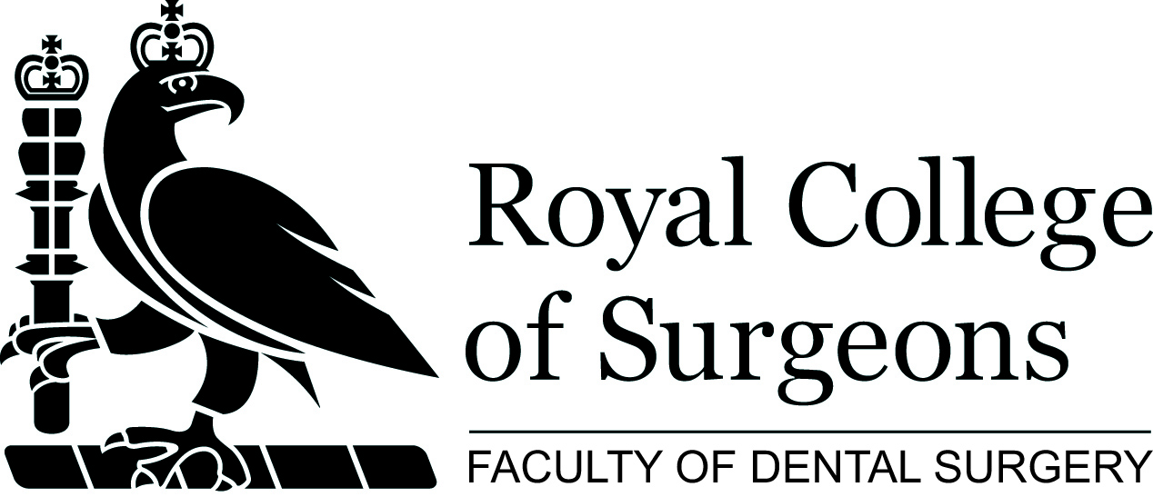

Masterclass in Special Care Dentistry: Thursday 28 March 2019
Venue: Royal College of Surgeons, Webb Johnson Hall

Time | Topic
0900-0930 | Registration & morning coffee
0930-0935 | Welcome / Introduction to the day  Dr Jane Temple  DSCD Chair/Consultant Derbyshire Community NHS Foundation Trust
0935-1020 | The hypersensitive gag reflex, why does it happen and how can we help the patient?  - To investigate what causes the hypersensitivity  - To explore the use of sedation to reduce the hypersensitivity  - An overview of the use of acupuncture in dentistry  Dr Chris Dickinson, Consultant at Guy’s & Thomas’ NHS Foundation Trust and Honorary Senior Lecturer, King’s College London Dental Institute
1020-1100 | Hypnosis and mindfulness  - To gain an understanding of the use of hypnosis in dentistry  - To understand how mindfulness can have a role in helping patients access dental care  - Examples of clinical cases  Dr Amar Kaul  Consultant at King’s College Healthcare
1100-1120 | Coffee break
1130-1215 | MRONJ Update  Update on the epidemiology, clinical manifestations, risk factors, and treatment of medication-related osteonecrosis of the jaws (MRONJ)  To understand the epidemiology of MRONJ  - To be aware of the risk factor of MRONJ  - To recognise the clinical manifestations of MRONJ  - To understand the principles of therapy of MRONJ  - To understand current knowledge gap and research needs  Professor Stefano Fedele DMD, PhD  Stefano Fedele is Professor of Oral Medicine at University College London, Eastman Dental Institute (UCL EDI), and Honorary Consultant in Oral Medicine at University College London Hospital, Eastman Dental Hospital (UCLH EDH)
1215-1255 | Dental treatment of patients with epidermolysis bullosa  - To understand the condition  - To gain an overview of the barriers to dental care and how they can be overcome  Dr Chris Dickinson Consultant at Guy’s & Thomas’ NHS Foundation Trust and Honorary Senior Lecturer, King’s College London Dental Institute
1300-1345 | Lunch
1345-1600 | Parallel session 1: examination preparation to include guidance of the structure of the DSCD part b examination  - Structured clinical reasoning exercises  - Examples of log diary/portfolio provided for review  - Opportunity to speak to examiners about DSCD specific queries  Chaired by Dr Jane Temple
1515-1530 | Coffee break
1345-1600 | Parallel session 2: examination preparation  - Special care dentistry cases and scenarios will be presented and discussed  - Interactive session with a focus on risk assessment and risk reduction  Chaired by Dr Navdeep Kumar
1600-1630 | Question and answer session

