Updated July 2017

Registered Charity No 212808

THE FACULTY OF DENTAL SURGERY
THE ROYAL COLLEGE OF SURGEONS OF ENGLAND
REGULATIONS FOR THE EXAMINATION OF THE DIPLOMA IN DENTAL PUBLIC HEALTH

1. ELIGIBILITY FOR THE AWARD OF THE DIPLOMA

To be eligible for the Diploma in Dental Public Health, all candidates must:

- Have held a primary dental qualification equivalent to a Bachelor of Dental Surgery for at least one year, which is registrable with the General Dental Council;

- Have satisfactorily completed the prescribed course of instruction or demonstrate equivalent professional experience (Regulation 2);

- Have complied with all the regulations and paid the Diploma Completion Fee.

2. THE MANDATORY TRAINING

All candidates must satisfactorily complete a suitable course of instruction in dental public health or public health that includes dental public health, at a recognised educational institution in the United Kingdom or elsewhere at the discretion of the College.

If candidates are not completing a recognised masters course in dental public health or public health they may be required to provide proof of the duration and content of the dental component of their course or be able to demonstrate equivalent professional experience (Appendix I).

It is expected that the course of instruction will be equivalent to 540 hours of learning of which not less than one third i.e. 180 hours be spent in a combination of face-to-face teaching or moderated e-learning (to include on-line seminars/tutorials, supervised discussion groups and journal clubs).

3. THE EXAMINATION

The diploma in dental public health examination will consist of:

- A written paper comprised of structured essay questions.

- A written paper comprised of short answer questions.

- A structured clinical reasoning section comprising four stations.

Copies of exemplar questions are available on request from the Examinations Department.
4. THE SCOPE OF THE EXAMINATION.
The following synopsis is intended to indicate the general scope of the examination only. A more detailed syllabus is available on the College website.

- Principles of public health
- Public health aspects of dental services
- Epidemiology of dental and oral diseases
- Oral health improvement
- Evidence based dentistry
- Health and public protection

5. APPLICATION FOR ADMISSION TO THE EXAMINATION.

- Applications must reach the Examinations Department, The Royal College of Surgeons of England, no later than the closing date as indicated on the examination calendar. Applications must be accompanied by the required certificates and the full amount of the fee payable for the examination.

- The dates and fees of the examinations are published annually in the examinations calendar obtainable free of charge from the Examinations Department.

- A candidate who, in writing, withdraws an application for admission may be refunded the fee paid, less a 20% administrative charge, provided that notice of intention to withdraw is received by the Examinations Department before the closing date by which applications are due, as shown in the examinations calendar. No refunds are made to candidates who withdraw after the closing date.

Applications for consideration for withdrawal on medical or compassionate grounds must be submitted to the College with a medical certificate within 28 days of commencement of the examination.

- The Faculty may refuse admittance to the examination or to proceed with the examination of any candidate who infringes the Regulations or who is considered by the examiners to be guilty of behaviour prejudicial to the proper management and conduct of the examination.

APPENDIX I

Please contact the Chair of the Examiners via Examinations Department at The Royal College of Surgeons of England by email if you require confirmation of the suitability of the course of instruction.
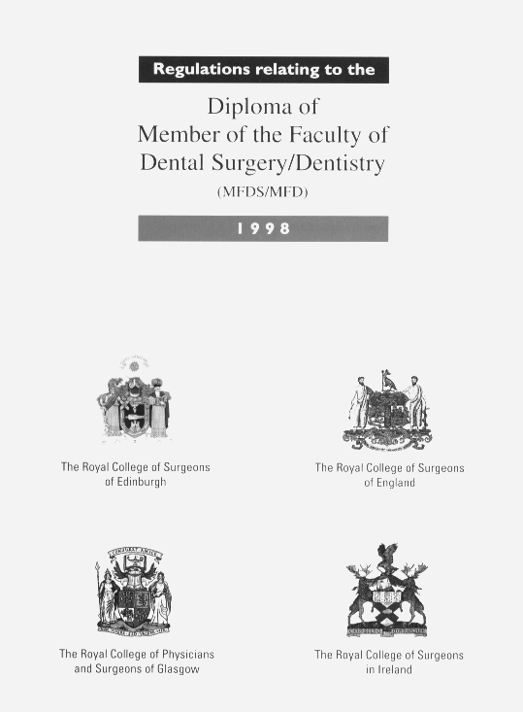

THE ROYAL COLLEGE OF SURGEONS OF ENGLAND

- The candidate, having passed all parts of the examination for the Diploma of Member of the Faculty of Dental Surgery shall be given a Notice subscribing his/her name to the Bye-Law and the required declaration; that it rests with the Board of Faculty to confer upon them the Diploma of Member; and that until the granting of such a Diploma by the Board, they are not in any circumstances, entitled to make use of the letters DDPHRCS Eng. after their name, to exercise any other rights conferred by the membership, or be admitted as visitors to the examination.

2. Upon confirmation by the Board of Faculty the successful candidate shall then receive a Diploma bearing the Seal of the College and the Diploma shall state that such Member has been successful in the examination.

Every Member shall pay each year such annual subscription as may be determined from time to time by the Board of Faculty with the concurrence of the College Council.

