Personalise your preferences to receive Current Awareness Updates.

Personalise your experience
RCS launched a new website in September 2016. New benefits and features include the ability to ‘personalise’ your experience. From the new ‘my-account’ area you can now easily change your communication preferences and tailor your interactions with us, so that we can provide you with more relevant information. This includes the ability to sign up to specialty specific Updates from the Library’s Current Awareness Service.
Current Awareness Service
The Current Awareness Service was originally built on the recommendation of RCS members, and having been on hiatus is about to re-launch with a new and improved service based on further feedback. As before, the Updates will contain the latest evidence in a particular surgical field compiled by Information Specialists with the help of clinical advisors. Selected article citations, guidelines and news items are sorted by topic within a given specialty, allowing highly-specialised consultants to focus on their chosen subspecialty. Most citations featured a helpful brief summary and link directly to the full text of the article, where covered by the College’s numerous subscriptions to e-journals.
Receive specialty-specific Updates
To ensure that you receive this service as part of your membership benefits please ensure that you update your profile on the website.

Step 1: Log in to the College website
Step 2: Click on your name in the top right hand corner in order to access your profile
Step 3: From the My Account section on the right select Account Preferences
Step 4: On this page choose your Surgical Specialty and click update Interests
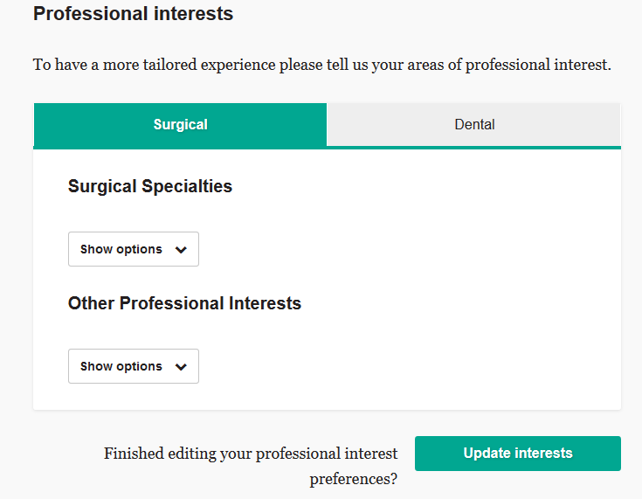
Step 5: Finally if you scroll down the page you will see an option for Journals under the Communications heading. In this section select Current Awareness Service and click Update email preferences.
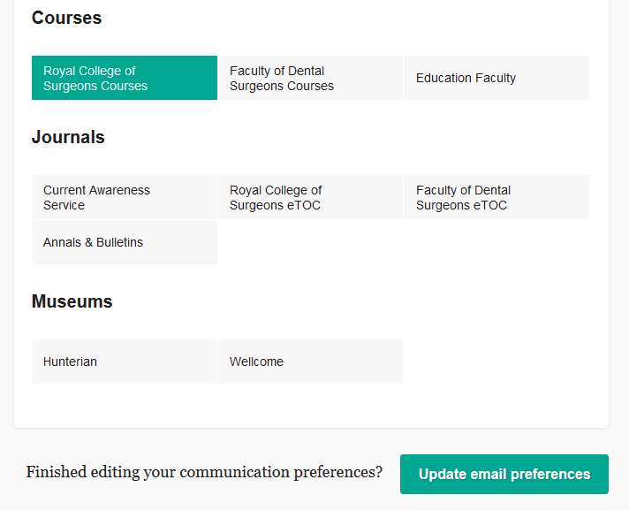

Once you have updated this information you will receive the Updates once the service is re-launched. It is also very easy to change your preferences again at any time.

If you would like to receive an Update outside of your own surgical specialty please email the Current Awareness Service team and we will add your details to other mailing lists.

