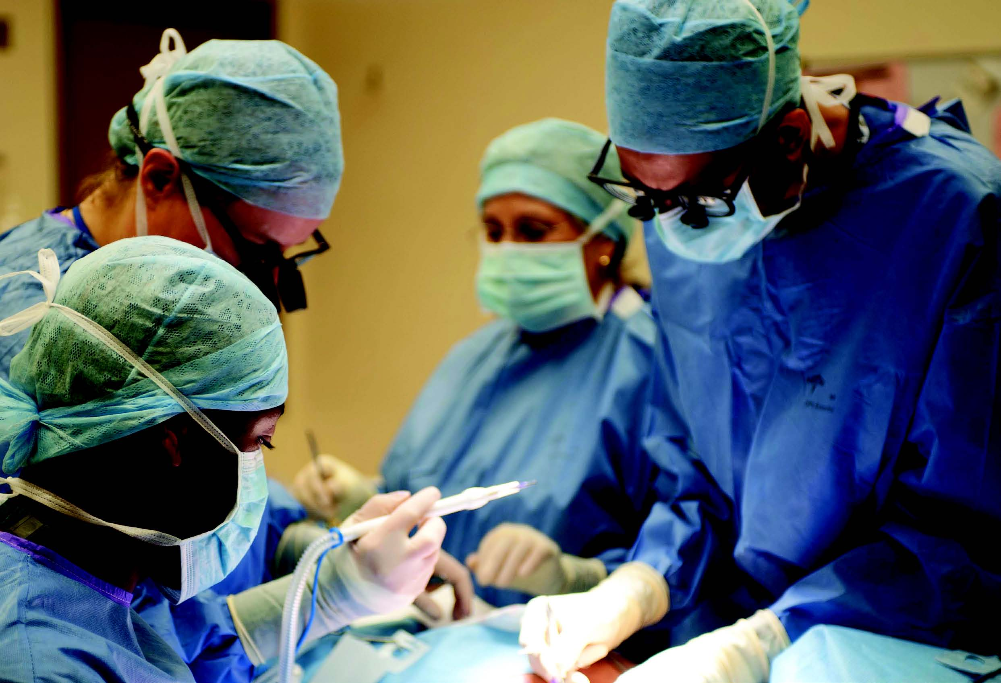
Surgical Specialty Lead Application Form
Gynaecological Oncology Surgery

Surgical Specialty Lead

RCS and British Gynaecological Cancer Society (BGCS) are inviting application for the role of Surgical Specialty Lead for Gynaecological Oncology Surgery.

Requirements
- Deadline for applications is Noon on Friday 16th July 2021
- Shortlisted candidates will be interviewed via a virtual platform from 1600 on Friday 31st July 2021. Please save this date as an alternative date for interviews will not be provided.
- This post is supported by BGCS. Successful candidate will be a member of BGCS.

Contact

- For information regarding the role please contact:

  - Professor Sudha Sundar
Professor of Gynaecological Oncology, University of Birmingham
President, British Gynaecological Cancer Society.
S.S.Sundar@bham.ac.uk

  - Professor Peter Hutchinson
Professor of Neurosurgery, University of Cambridge
Director of Clinical Research, Royal College of Surgeons of England
pjah2@cam.ac.uk
  - Mr Dale Vimalachandran
Consultant Colorectal Surgeon, Countess of Chester NHS Foundation Trust
Colorectal Surgical Specialty Lead, Royal College of Surgeons Surgical Trials Initiative
dale.vimalachandran@nhs.net

- For information regarding the application process please contact Murat Akkulak makkulak@rcseng.ac.uk. All completed applications to be sent to research@rcseng.ac.uk.

Section 1

1.1 - Contact Details

Individual
Title |  | Initials
First Name
Last Name

Unit
Department
Faculty / School
Host Institution
Address
Postcode
Email
Telephone
Alternate/Secretary Email

Section 2 - Experience of Surgical trials

2.1 Please describe your experience to date, of working on multicentre clinical trials (500 words)

2.2 Please provide 3 examples of multicentre trials to which you have contributed.

Name of trial
NIHR Portfolio status |  | Trial Design
Surgical Discipline
Chief Investigator |  |  |  | Speciality
Your Role (e.g. PI/CI)
Your contribution
(< 50 words)

Name of trial
NIHR Portfolio status |  | Trial Design
Surgical Discipline
Chief Investigator |  |  |  | Speciality
Your Role (e.g. PI/CI)
Your contribution
(< 50 words)

Name of trial
NIHR Portfolio status |  | Trial Design
Surgical Discipline
Chief Investigator |  |  |  | Speciality
Your Role (e.g. PI/CI)
Your contribution
(< 50 words)

2.3 Please outline a plan for how you will develop new researchers (including trainees) and new studies over the next 3 years (500 words)

Section 3 - Research Proposal Outlines

Please give one example of a surgical trial that you plan to work up

3.1.1 - Research project title

3.1.2 - Proposed start date

3.1.3 - Duration of project

3.1.4 - Research goals
Please summarise the primary goals of your research in a format that can be understood by a non-specialist audience in no more than 100 words.

3.1.5 – Proposed funding
stream

Section 4 - Curriculum Vitae

Please submit a curriculum vitae (limited to 4 sides of A4) including qualifications, relevant employment history, recent publications and details of clinical research grants.
Please included evidence of support for your application from the Medical Director of your current NHS Employer
End of form
The Royal College of Surgeons of England
35-43 Lincoln’s Inn Fields
London WC2A 3PE
T: 020 7869 6051
E: gsp@rcseng.ac.uk

