
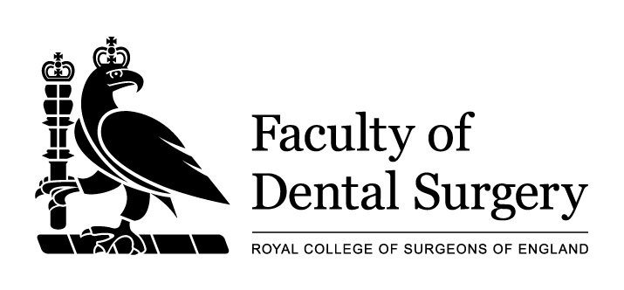

2023 Faculty of Dental Surgery Research Fellowships

APPLICATION FORM FOR:

The FDS RCSEng- British Orthodontic Society (FDS RCSEng-BOS) Research Fellowship

Please read the NOTES below. For full details and Terms and Conditions potential applicants must consult the FDS Research Fellowships guidelines, which are available on our website:

https://www.rcseng.ac.uk/fds/research/fds-research-fellowships

Notes:

The FDS RCSEng-BOS fellowships are normally for one year and must be taken up within 12 months of the award being made.

Fellowships will not be awarded to applicants who already have a PhD or equivalent.

Fellowships will not be awarded to applicants who have previously been awarded an FDS-BOS Fellowship.

At the point of application applicants must be members of FDS RCSEng and the British Orthodontic Society and in good standing with both organisations.

Applicants for Fellowships are normally interviewed in April each year.

NOTES

Before completing the application form, please read the notes given below and the Terms and Conditions of the FDS Research Fellowships. These are available at:

https://www.rcseng.ac.uk/fds/research

- Applicants should read the enclosed Terms and Conditions. Submission of an application will be taken to imply acceptance of these Regulations.

- Applicants should submit only completed forms and should arrange for these forms to be in clear typescript.

- All questions must be answered or marked “not applicable”.

- Applicants should return all parts of the application form by 06 January 2023 at 5pm to:
Ms H Johnstone hjohnstone@rcseng.ac.uk.

- Application forms must conform to the presented layout and provide the necessary information within the space(s) provided on the form. Applications which exceed the word count will not be reviewed.

- The Application Form comprises three parts which must all be completed:

Part A - to be completed by the applicant
Part B - to be completed by the applicant’s proposed Supervisor (s) and proposed Head of Department
Part C - to be completed by the appropriate Administrative/Finance Officer(s) of the proposed Host Centre

Applicants are responsible for passing parts B and C of the application form to the appropriate authorities for completion and for ensuring that each are returned to the College by the closing date.

- Any queries should be emailed to Ms H Johnstone – hjohnstone@rcseng.ac.uk.
- Application forms received after the closing date will not be accepted.
- Receipt of application forms will be acknowledged in writing within seven days of the closing date.

In line with UK legislation and good practice guidelines, we are asking everyone to complete the Equal Opportunities Questionnaire. You are not obliged to provide any of the information, but if you do so, it will enable us to monitor our business processes and ensure that we provide equality of opportunity to all.

Application Form – Part A (APPLICANT)

1. Your personal and contact details
Title:
Forename/s (in full):
Surname:
Home Address:

E-mail:
Telephone No:
Mobile No:

2. Fellowship details
Title of Project:
(no more than 80 characters including spaces)

Proposed Fellowship start date:
Proposed Duration of Fellowship:
Place where study would take place:
Address of Centre:
Email:
Telephone No:
Area of Study:
Keywords:
(Give three keywords which encapsulate your study)

3. Name and title of proposed Head of department and proposed supervisor(s) to whom Part B has been passed:
Head of Department:
1st Supervisor:
2nd Supervisor:
(if appropriate)
3rd Supervisor:
(if appropriate)

4. To apply for this award the candidate must have an affiliation with the Faculty of Dental Surgery of the Royal College of Surgeons of England.
Please state which of the following you hold: | MFDS RCS England  MJDF RCS England  FDS RCS England  None of the above
Please confirm that you are a member of the British Orthodontic Society | YES NO

5. Academic and Professional Qualifications (in date order, earliest first):
Awarding Institution | Qualification | Class | Subject | Year of award

6. Details of present appointment:
(A) | Employer/source of funding
(B) | Tenure (if untenured please give date of termination of current post)
(C) | Grade/status
(D) | Dental/medical specialty (if applicable)
(E) | Present basic annual salary
(F) | Next incremental date
(G) | Date of entry to current grade
(H) | National Training Number (NTN) (if applicable)
(I) | If you are currently registered for a PhD or other postgraduate qualification please specify what this is, the date of registration, and the institution where you are registered

- Postgraduate career including present employment.
(in date order, earliest post first):
Place of work | Post held | Dates

8. Publications in refereed journals.
State journal, title and page numbers (first and last) and names of co-authors (details of papers in press must be stated clearly but abstracts should not be included):

9. Research experience:
Summary of academic career to date, including key achievements, and previous research experience (no more than 700 words).

10. Research training:
What training do you hope to gain and from whom? Please indicate why you wish to undertake a research training fellowship and how this will further your career (No more than 500 words).

11. Please state briefly the scientific considerations that led you to choose the host centre (and supervisors) named at Part A (page 3). (No more than 500 words).

12. Provide a simple description of the proposed research in terms that members of the general public can readily understand. This should include:

1. Simple project title.
2. Background/rationale for the study.
3. Aim of the study.
4. Overall study design.
5. Potential impact or benefit for patients/health services.

(No more than 500 words).

13. Details of research to be undertaken: (no more than 1500 words)
Indicate what your research question is, and why it is important. Detail (a) Aims of the project, (b) Work which has led up to the project, (c) Timetable and milestones, (d) What key methodologies and techniques will the fellow use to achieve the aims of the project.

Graphs and/or figures may be embedded in the text and are excluded from the word count.

14. References (relating to section 13 above)
Please give citation in full, including title of paper and all authors.

15. Please detail how you will ensure appropriate public and/or patient engagement within your proposed research (no more than 300 words).

16. Career intentions.
(outline how this fellowship will support your overall future career aims including plans for future grant applications and specialist training): (no more than 200 words)

17. Research grants from other funding agencies.
Please state whether you have had additional funding prior to this research and from whom:

18. Is this project/study title currently under consideration by another funding organisation? If so which organisation? When will you know the outcome?

19. Further funding
Please state whether you intend to seek further funding: (double-click box to check) | YES NO
If answered yes  (double-click box to check) | For one more year  For two more years  Other

20. Applicant’s Declarations:
If I am successful in obtaining this award, I agree to:  - Acknowledge the support of the Faculty of Dental Surgery of the Royal College of Surgeons of England and British Orthodontic Society and include such wordings in all manuscripts.  - Submit a copy of the accepted paper to the Faculty of Dental Surgery’s Research Committee upon its acceptance in a journal.  - Attend at least one public engagement event for the Faculty of Dental Surgery and British Orthodontic Society. | YES NO  YES NO  YES NO

21. Acceptance of regulations and conditions:
I have read the Regulations and Conditions for The Royal College of Surgeons of England Dental Research Fellowships and, if my application is successful, I agree to abide by them.
SIGNATURE: | DATE:

