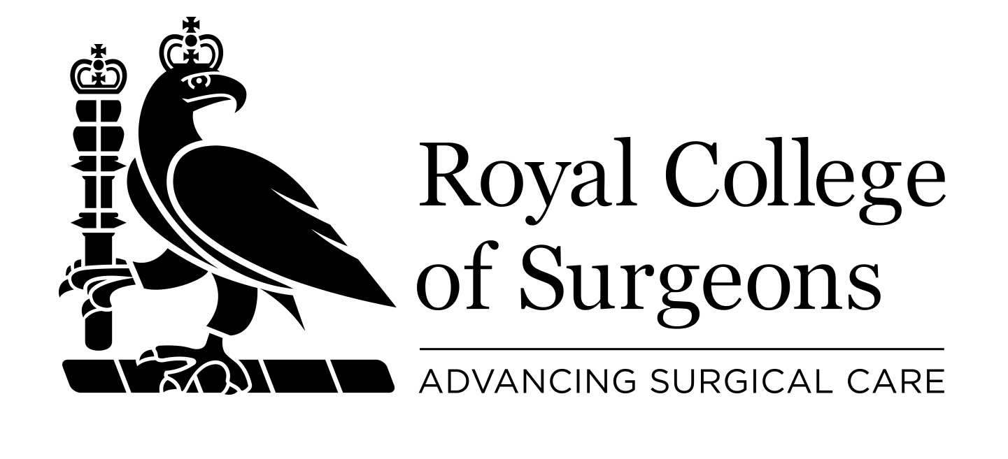
Christmas Appeal 2019

Help us improve access to surgical care for children with inguinal hernia in Nepal

Please print and complete all sections
Name
Address
Postcode
Telephone Email

I would like to make a donation of  £20  £50  £100  Other

Please choose your method of payment:

 I enclose a cheque made payable to The Royal College of Surgeons of England

 Please debit my (circle as applicable): VISA | Mastercard | CAF Charity Card:

Card number _ _ _ _ | _ _ _ _ | _ _ _ _ | _ _ _ _

Security code _ _ _ Issue number _ _ _ Start date _ _ / _ _ Expiry date _ _ / _ _

You can donate on line at www.rcseng.ac.uk/donate

Gift Aid Declaration


Make your donations worth more to the RCS at no extra cost to you. By making a Gift Aid declaration you will allow the College to reclaim tax on your donation which increases your donation by 25p for every £1 you donate You must pay an amount of income tax and/or capital gains tax at least equal to the tax that we will reclaim on your donations in the tax year.

Signature ……………………………………… Date: ………………………….

Stay in touch

We would like to continue to keep you up to date with RCS charity news and opportunities to support our work. Please tick here if you wish to hear from us: Post: Yes □ No □ Email: Yes □ No □

If at any time you change your mind, please call 020 7869 6086. Your personal information is safe with us and is held in our secure database.

Please return this form to Development Office, The Royal College of Surgeons of England, 35-43 Lincoln’s Inn Fields, London, WC2A 3PE

