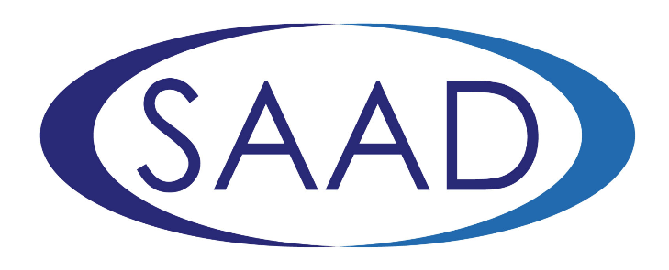

FDS RCSEng- Society for the Advancement of Anaesthesia in Dentistry
(FDS RCSEng-SAAD)

- Pump-Priming Grants Stage 1 Application Form

- Closing date: Monday 7 November 2022 at 5pm.

- Applicants will be informed of the outcome of this first stage application process mid-November and successful applicants will be invited to submit a more detailed 2nd stage application (closing date 13 January 2023, 5pm).

- Financial details: The FDS RCSEng-SAAD Pump-Priming grants will be for up to £10,000 and are intended to support research designed to benefit community or population oral health, and should be related to conscious sedation in dentistry. Applicants should be in early stages of a research career (e.g. pre-doctoral). Applicants may be working in any field of dentistry, but must be members in good standing of SAAD. On completion of their research project, successful applicants will be expected to present their research at a SAAD conference.

Applicants need not be a Fellow or Member of FDS RCS England at the time of the stage 1 application. However, if successful in being invited to apply for stage 2, and not already a member or fellow of FDS RCS England, the applicant will be required to apply to the Awards Committee for the award of Fellow or Member ad Eundem if eligible, and take up FDS RCS England membership before submitting a stage 2 application. If fellowship or membership is offered, they will be expected to pay an annual subscription to RCS England for the duration of the grant. Those who are not eligible for membership (e.g. DCPs) can hold the grant without FDS RCS England membership.

- The Pump-Priming grants scheme DOES NOT cover: personal salaries and staffing costs, travel or living expenses not related to the research itself (e.g. conference travel), IT equipment which is not directly related to the research project (personal laptops etc) or fees for courses, higher degrees or open-access publication costs.

- Please read the form carefully and ensure that all sections of the form are completed. Applications which exceed the word limits will not be considered. Please complete and submit one copy only to: Ms H Johnstone hjohnsto@rcseng.ac.uk

SECTION 1: Your Personal and Contact Details
Title:
Forename/s (in full):
Surname:
Home Address:

E-mail:
Telephone No:
Mobile No:
Dental/Medical Specialty (if applicable):
Current Position (grade and employer/service setting):
Please confirm that you are a member of SAAD | YES NO
Please confirm your FDS RCS Eng membership number
Please confirm that you do not already have a PhD or equivalent | CONFIRMED NO PhD or equivalent

SECTION 2: Primary Supervisor Details
Title:
Name:

Address:
Telephone No:
Email:
Signature: |  | Date:
By signing this form, the supervisor confirms that the Host institution can accommodate the applicant and that the terms and conditions including the financial arrangements can be met. The supervisor is advised to consult with the head of the institution and with the appropriate finance officer

SECTION 3: TITLE OF PROJECT
Plain English Summary of Research (This should be a brief summary of the proposed research which is aimed at members of the public, rather than researchers or professionals. It should be written clearly and simply and should provide some background to the research, the aim and overall approach planned)

Do not exceed 300 words.

SECTION 4: Research Plan (This should include the aim/objectives of the proposed research and details of the design/methods. Also include a brief timeline and indication of the likely costs)

Do not exceed 500 words.

SECTION 5: Applicant’s Declarations:
If I am successful in obtaining this award, I agree to:  - Acknowledge the support of the Faculty of Dental Surgery of the Royal College of Surgeons of England and SAAD and include such wordings in all manuscripts.  - Submit a copy of the accepted paper to the Faculty of Dental Surgery’s Research Committee upon its acceptance in a journal.  - Contribute to at least one public engagement event for the Faculty of Dental Surgery and SAAD. | YES NO  YES NO  YES NO

APPLICANT’S SIGNATURE: | DATE:

In line with UK legislation and good practice guidelines, we are asking everyone to complete the Equal Opportunities Questionnaire. You are not obliged to provide any of the information, but if you do so, it will enable us to monitor our business processes and ensure that we provide equality of opportunity to all.

